A Small World
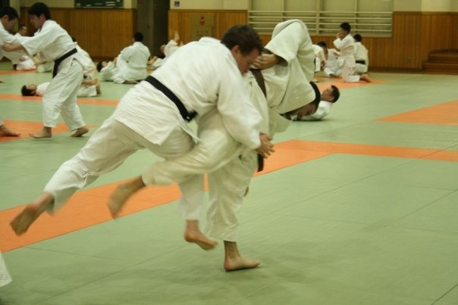18-yr-old Hayden Miller travelled a long way to train for the Maccabiah.

Earlier this year, he took time off to stay in Tokyo as he trained at the Kodokan Judo Club, one of the nerve centres of his favourite sport, Judo.

As one would normally expect, Hayden gravitated towards another English-speaking exponent of the sport...22-yr-old Alex Gold from the U.K.

The two got talking and within in no time at all discovered they were both Jewish and both selected for their respective countries to compete in the Maccabiah.

Hayden is looking forward to renewing his friendship with his former training partner but as luck has it, they will not be competing against each other in Israel as they are in different weight divisions.

Alex is the UK's only competitor in the sport. Australia will field two.

Alex and Hayden will spur each other on as long as Alex is not fighting Australia!

In the photo, Alex is on the left...seen training with Hayden

